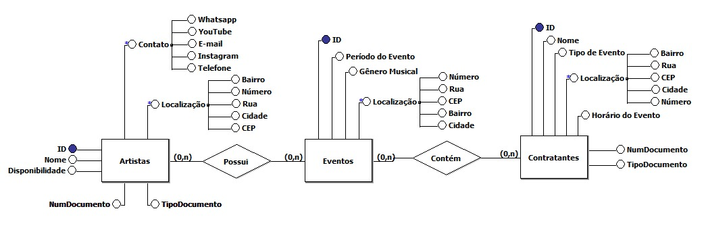**MODELO CONCEITUAL**

**Modelo Lógico**

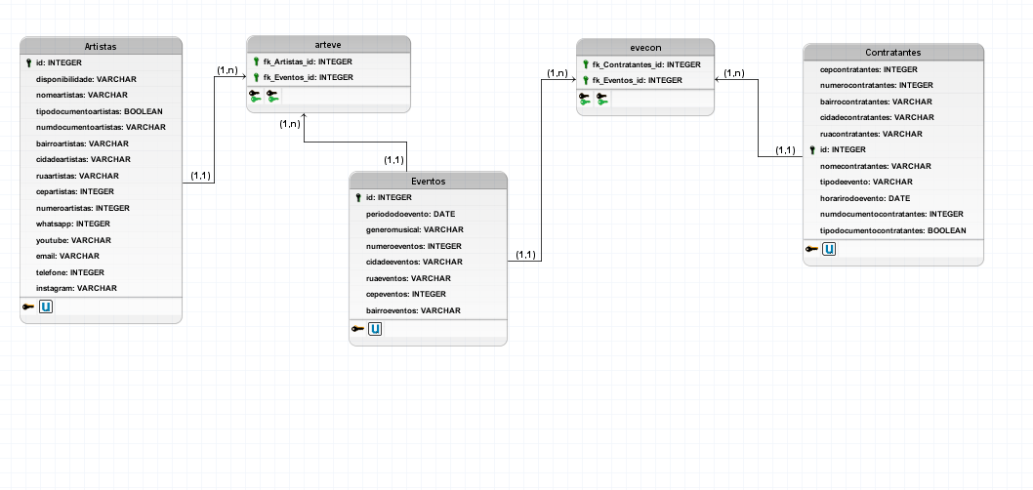

**Modelo Físico**

create database bd_handshake;

use bd_handshake;

/* Conceitual: */

CREATE TABLE Artistas (

idartistas INTEGER PRIMARY KEY,

disponibilidade VARCHAR(15) not null,

nomeartistas VARCHAR(32) not null,

tipodocumentoartistas BOOLEAN not null,

numdocumentoartistas VARCHAR(14) UNIQUE not null,

bairroartistas VARCHAR(32) not null,

cidadeartistas VARCHAR(32) not null,

ruaartistas VARCHAR(50) not null,

cepartistas VARCHAR(8) not null,

numeroartistas VARCHAR(5) not null,

whatsapp VARCHAR(13) not null,

youtube VARCHAR(100) not null,

email VARCHAR(60) not null,

telefone VARCHAR(12) not null,

instagram VARCHAR(50) not null

);

CREATE TABLE Eventos (

ideventos INTEGER PRIMARY KEY,

periododoevento DATE not null,

generomusical VARCHAR(32) not null,

numeroeventos VARCHAR(5) not null,

cidadeeventos VARCHAR(32) not null,

ruaeventos VARCHAR(50) not null,

cepeventos VARCHAR(8) not null,

bairroeventos VARCHAR(32) not null

);

CREATE TABLE Contratantes (

cepcontratantes VARCHAR(8) not null,

numerocontratantes VARCHAR(5) not null,

bairrocontratantes VARCHAR(32) not null,

cidadecontratantes VARCHAR(32) not null,

ruacontratantes VARCHAR(50) not null,

idcontratantes INTEGER PRIMARY KEY,

nomecontratantes VARCHAR(50) not null,

tipodeevento VARCHAR(32)not null,

horarirodoevento DATE not null,

numdocumentocontratantes VARCHAR(14) UNIQUE not null,

tipodocumentocontratantes BOOLEAN not null

);

CREATE TABLE evecon (

fk_Contratantes_id INTEGER,

fk_Eventos_id INTEGER

);

horar

CREATE TABLE arteve (

fk_Artistas_id INTEGER,

fk_Eventos_id INTEGER

);

ALTER TABLE evecon ADD CONSTRAINT FK_evecon_1

FOREIGN KEY (fk_Contratantes_id)

REFERENCES Contratantes (id)

ON DELETE RESTRICT;

ALTER TABLE evecon ADD CONSTRAINT FK_evecon_2

FOREIGN KEY (fk_Eventos_id)

REFERENCES Eventos (id)

ON DELETE RESTRICT;

ALTER TABLE arteve ADD CONSTRAINT FK_arteve_1

FOREIGN KEY (fk_Artistas_id)

REFERENCES Artistas (id)

ON DELETE RESTRICT;

ALTER TABLE arteve ADD CONSTRAINT FK_arteve_2

FOREIGN KEY (fk_Eventos_id)

REFERENCES Eventos (id)

ON DELETE RESTRICT;

insert into artistas

values

('1','manhã','jhonata','0','50040030009','sao jose','jaboatao','travessa 1','52100211','21','5581998404050','www.youtube.com1','artista@gmail.com','81998404050','www.instagram.com0'),

('2','personalizado','lucas','0','11100022244','sao antonio','olinda','travessa 2','0011122','11','5581999999999','www.youtube.com2','artista1@gmail.com','081998999999','www.instagram.com1'),

('3','noite','victor','0','11100022255','sao pedro','recife','travessa 3','0011133','31','5582999999999','www.youtube.com3','artista2@gmail.com','081999999999','www.instagram.com2'),

('4','noite','thiago','0','11100022256','sao pedro','recife','travessa 11','0011133','31','5582999978999','www.youtube.com3','artista2@gmail.com','081999999999','www.instagram.com2'),

('5','integral','matheus','1','11100022233111','sao paulo','camaragibe','travessa 4','0011144','41','5583999999999','www.youtube.com4','artista3@gmail.com','081999899999','www.instagram.com3'),

('6','noite',' washington','1','11100022233222','sao tiago','sao lorenço','travessa 5','0011155','51','5584999999999','www.youtube.com5','artista4@gmail.com','081998999999','www.instagram.com4'),

('7','integral','marques','1','11100022233444','sao judas','moreno','travessa 6','0011166','61','5585999999999','www.youtube.com6','artista5@gmail.com','081999999998','www.instagram.com5'),

('8','personalizado','barros','0','11100022266','sao tadeu','cabo','travessa 7','0011177','71','5586999999999','www.youtube.com7','artista6@gmail.com','081999999989','www.instagram.com6'),

('9','noite','araujo','1','11100022233666','sao filipe','vitoria','travessa 8','0011188','81','5587999999999','www.youtube.com8','artista7@gmail.com','081999999899','www.instagram.com7'),

('10','manhã','fernando','0','11100022259','sao andre','paulista','travessa 9','0011199','91','5581989999999','www.youtube.com9','artista8@gmail.com','081999998999','www.instagram.com8'),

('11','horario comercial','henrique','1','11100022233777','sao joao','gravata','travessa 10','0011100','28','5581998999999','www.youtube.com/1','artista9@gmail.com','081979999999','www.instagram.com9');

insert into eventos

values

('1','10032020','jazz','455','jaboatao','rua 11','54101200','boa vista'),

('2','11032020','frevo','465','olinda','rua 12','54102200','boa viagem'),

('3','12032020','rock','457','camaragibe','rua 13','54103200','santo amaro'),

('4','13032020','brega','485','vitoria','rua 14','54104200','sao pedro'),

('5','14032020','funk','459','moreno','rua 15','54105200','sao paulo'),

('6','15032020','pagode','355','recife','rua 16','54106200','sao tadeu'),

('7','16032020','samba','255','paudalho','rua 17','54107200','sao cristovao'),

('8','17032020','pop','955','cabo','rua 18','54108200','sao lucas'),

('9','18032020','eletronico','855','limoeiro','rua 19','54109200','sao fernando'),

('10','19032020','rap','459','ipojuca','rua 20','54100201','sao mateus');

insert into contratantes

values

('00000010','45','santo amaro','caruaru','rua 21','1','kabum','aniversario',"2020-03-11",'111001001000','1'),

('00000009','46','santo antonio','paudalho','rua 22','2','nagem','festa',"2102-20-20",'121001001000','1'),

('00000008','47','santo pedro','abreu','rua 23','3','infobox','shopping',"2202-20-20",'131001001000','1'),

('00000007','48','santo paulo','olinda','rua 24','4','infohorse','formatura',"2302-20-20",'101001001000','1'),

('00000006','49','santo judas','paulista','rua 25','5','chipart','diversao',"2402-20-20",'141001001000','1'),

('00000005','20','santo abraao','jaboatao','rua 26','6','rockets','encontro',"2502-20-20",'151001001000','1'),

('00000004','80','santo davi','recife','rua 27','7','pichal','aniversario',"2602-202-0",'161001001000','1'),

('00000003','90','santo natanael','recife','rua 28','8','lojas americana','festa',"2702-20-20",'171001001000','1'),

('00000002','30','santo felipe','cabo','rua 29','9','submarino','formatura',"2802-20-20",'181301201000','1'),

('00000001','10','santo lebeu','limoeiro','rua 31','10','Dell','aniversario',"2902-20-20",'191001001000','1');

insert into arteve

values

('1','1'),

('2','2'),

('3','3'),

('4','4'),

('5','5'),

('6','6'),

('7','7'),

('8','8'),

('9','9'),

('10','10');

insert into evecon

values

('1','1'),

('2','2'),

('3','3'),

('4','4'),

('5','5'),

('6','6'),

('7','7'),

('8','8'),

('9','9'),

('10','10');